WIREFRAME

FOR LIBRARY MANAGEMENT SYSTEM

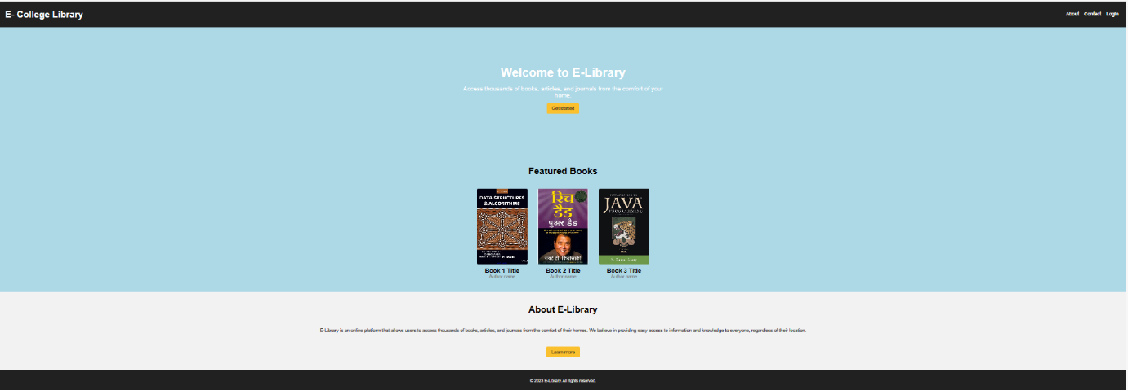**1.Home Page:**

**2. Student Registration Page:**

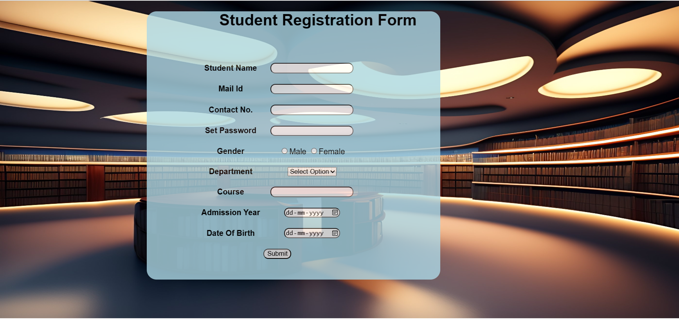

**3. Chooserole page:**

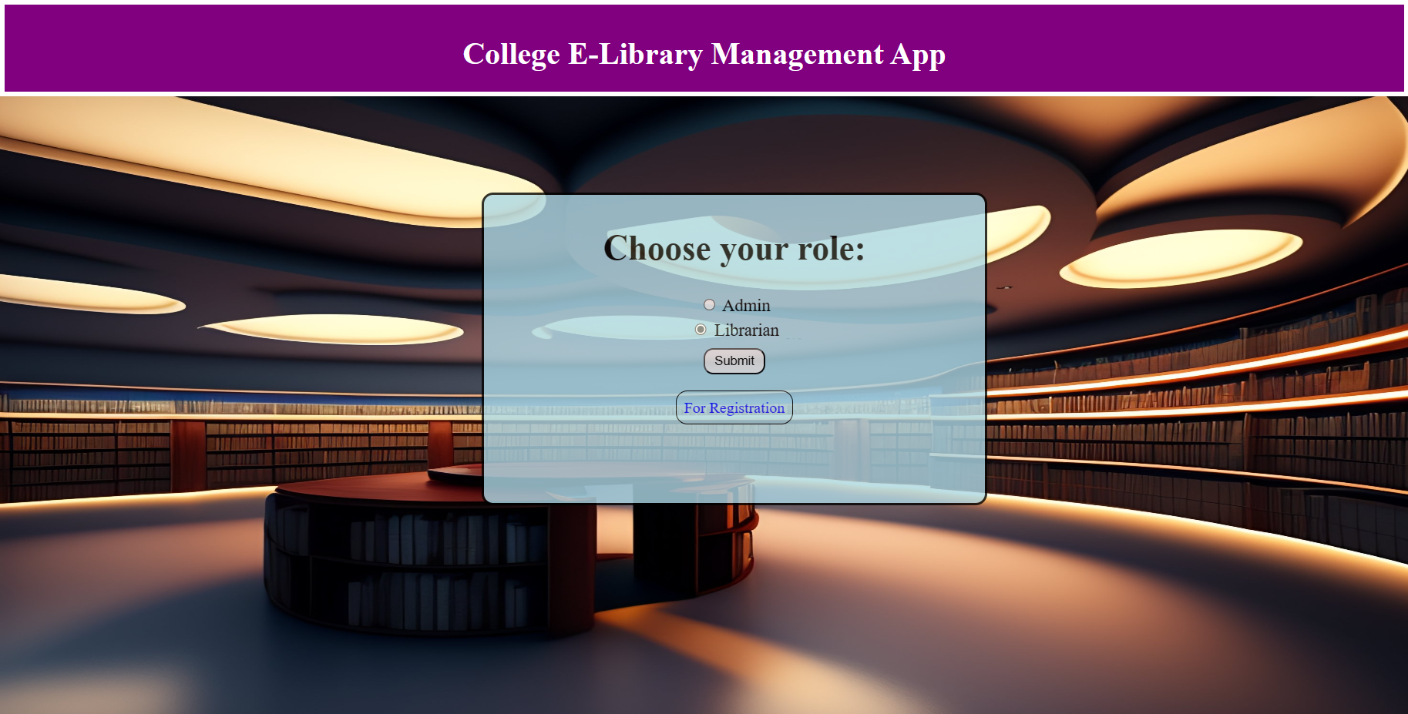

**4. Librarian Menu:**

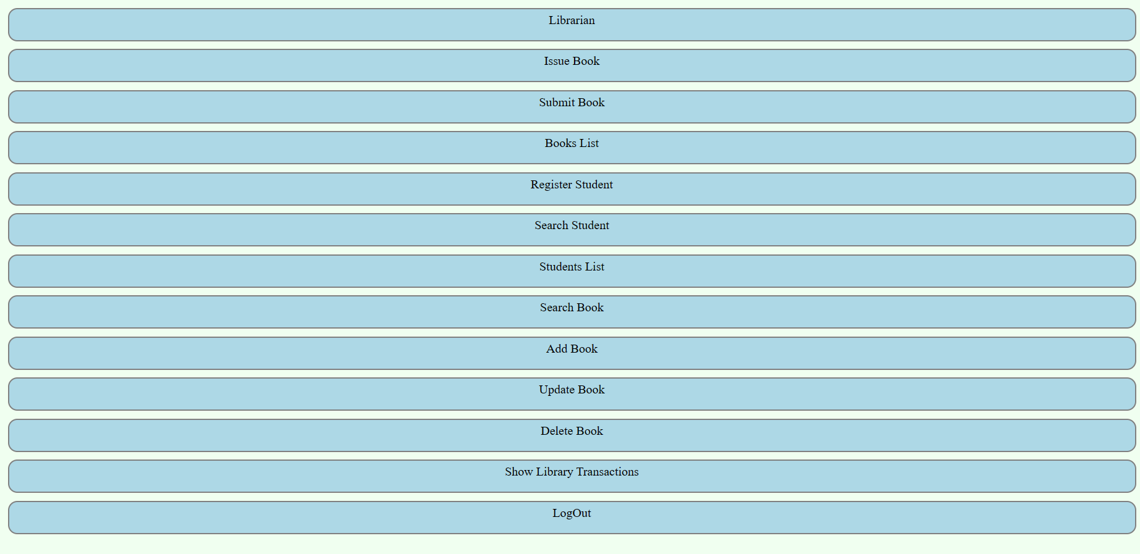

**5. Forms:**

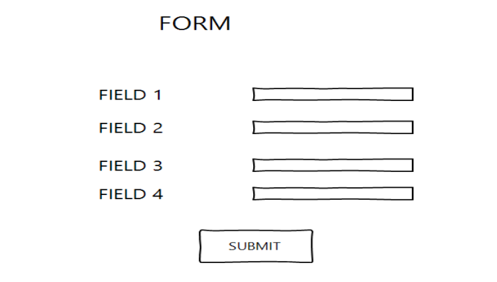

**6. Table:**

